**Starting Out with Visual Basic 2015**

**Chapter 1 Programming Challenges**

**4. Account Balance**

Step 1:

Purpose: Calculate the account balance

Input: The starting balance, the amount of deposits made, and the amount of withdrawals made.

Process: Calculate the account balance as starting balance + deposits - withdrawals.

Output: The account balance

Step 2:

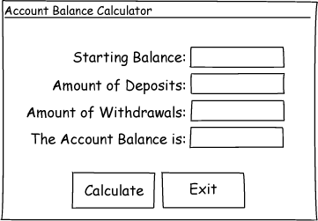

Step 3:

|  |  |
| --- | --- |
| Control Type | Name |
| Form | default |
| Label (for displaying "Starting Balance:") | default |
| Label (for displaying "Amount of Deposits:") | default |
| Label (for displaying "Amount of Withdrawals:") | default |
| Label (for displaying "The Account Balance is:") | default |
| TextBox | txtStartingBal |
| TextBox | txtDeposits |
| TextBox | txtWithdrawals |
| Label | lblBalance |
| Button | btnCalculate |
| Button | btnExit |

Step 4:

|  |  |
| --- | --- |
| Control | Text Property |
| Form | "Account Balance Calculator" |
| Label (default name) | "Starting Balance:" |
| Label (default name) | "Amount of Deposits:" |
| Label (default name) | "Amount of Withdrawals:" |
| Label (default name) | "The Account Balance is:" |
| txtStartingBal |  |
| txtDeposits |  |
| txtWithdrawals |  |
| lblBalance |  |
| btnCalculate | "Calculate" |
| btnExit | "Exit" |

Step 5:

|  |  |
| --- | --- |
| Method Name | Description |
| btnCalculate_Click | Add the amount of deposits to the starting balance, and subtract the amount of withdrawals from the starting balance. Store the result in the acctBalance variable. Store the value in the acctBalance variable in lblBalance.Text. |
| btnExit_Click | Ends the application. |

Step 6:

btnCalculate_Click

Flowchart:

Start

acctBalance variable = txtStartingBal.Text + txtDeposits.Text – txtWithdrawals.Text.

End

Store the value in the acctBalance variable in lblBalance.Text.

Pseudocode:

*acctBalance = txtStartingBal.Text + txtDeposits.Text – txtWithdrawals.Text.*

*lblBalance.Text = acctBalance.*

btnExit_Click

Flowchart:

Start

End the application.

End

Pseudocode:

*End*